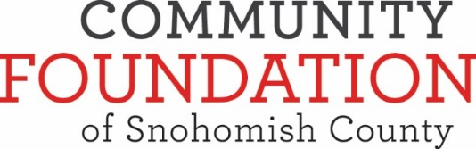
Grant Recommendation Form
Fund __________________________________________________________________
As an Advisor to the fund noted above, I recommend that the Board of Directors of the Community Foundation of Snohomish County consider
the following grant(s) to the nonprofit organization(s) for the purpose(s) described below.
Payable To  (Organization name and address) | Purpose  (i.e. operations, capital campaign, program name) | Grant Amount  (min. $250) | Office Use Only
 |  |  |  
 |  |  |  

I understand that this is a recommendation only, and that the Foundation’s Board of Directors has sole discretion for grants made from the Fund.
I attest that the recommendation above does not represent payment of a pledge or other personal financial obligations on behalf of the fund representative(s), family members or businesses they control and that no tangible benefit, goods or services, such as membership, dinners, tickets, etc., were, or will be, received by any individual or entities connected with the Fund (described above).

Signature of Advisor _________________ Date_________________________

Grant payments are processed every two weeks, usually the 2nd and 4th week of the month.

Grants paid from your fund are listed on your quarterly statement.

Submit completed forms to: Lisa@cf-sc.org  2823 Rockefeller Ave., Everett, WA 98201

